Lorus

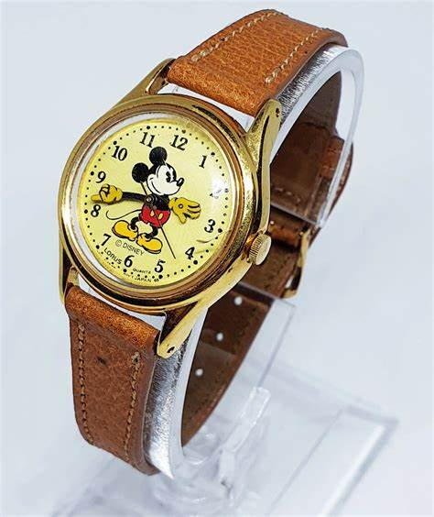

Description: **Lorus** is a popular and **affordable watch brand** that offers a wide range of stylish, reliable, and practical timepieces for both men and women. Known for their **high-quality craftsmanship**, **durability**, and **sleek designs**, Lorus watches provide a great option for those who want dependable watches without the high price tag of luxury brands. Lorus is a subsidiary of the **Seiko Group**, so they benefit from the precision and technology that comes from being part of a renowned watchmaking family.

Lorus watches typically feature **classic analog designs**, with a variety of **leather, stainless steel, and silicone bands**. They are designed to be **versatile**, making them perfect for both casual and formal wear. The brand offers a wide selection of **dress watches**, **sporty designs**, and **everyday wear** watches, appealing to a variety of tastes and preferences.